**Resource list and costs**

**Budget = 45,000**

**TOTAL for all staff: £15,335**

**Material total = £30500**

**Overall total = 45,835 (£835 over budget)**

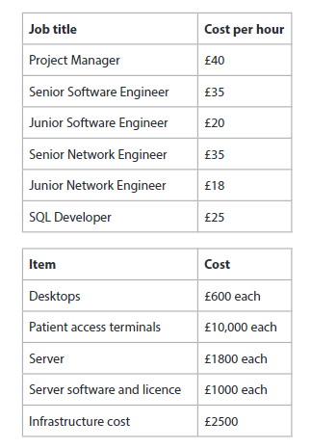

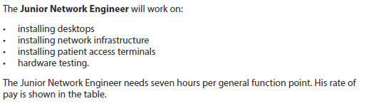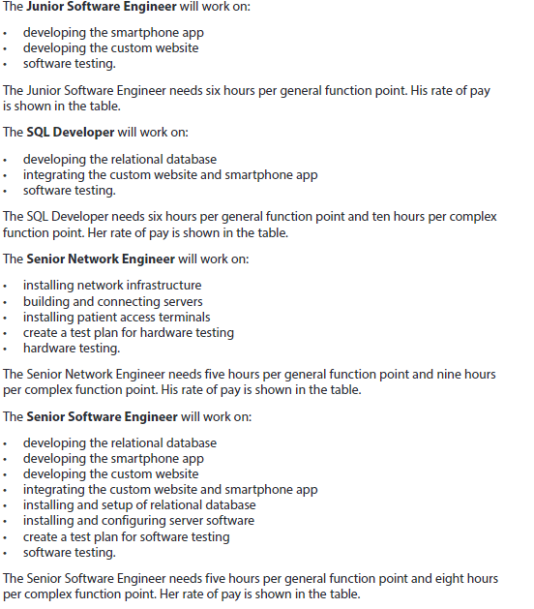

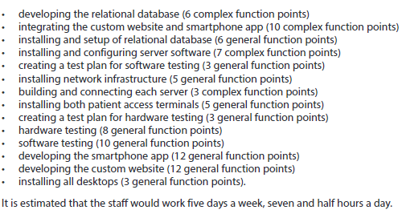

1. developing the relational database (6 complex function points)

Senior software engineer = 8 hours per general point

6 complex function points x 8 = 40

40 / 7.5 = 5.3 (days)

40 (hrs.) x £20 (per hour rate) = £800

1. integrating the custom website and smartphone app (10 complex function points)

SQL Developer = 10 hours per general point

10 complex function points x 10 = 100

100 / 7.5 = 13.3 (days)

100 (hrs.) x £20 (per hour rate) = £ 2000

1. installing and setup of relational database (6 general function points)

Senior Software Engineer = 5 hours per general point

6 general function points x 5 = 30

30 / 7.5 = 4 (days)

30 (hrs.) x £35 (per hour rate) = £ 1050

1. installing and configuring server software (7 complex function points)

SQL Developer = 8 hours per general point

7 complex function points x 8 = 56

56 / 7.5 = 7.5 (days)

56 (hrs) x £35 (per hour rate) = £1960

1. creating a test plan for software testing (3 general function points)

Senior software Engineer = 5 hours per general point

3 general function points x 5 = 15

15 / 7.5 = 2 (days)

15 (hrs) x £35 (per hour rate) = £525

1. installing network infrastructure (5 general function points)

Junior Network Engineer = 7 hours per general point

5 general function points x 7 = 35

35 / 7.5 = 8 (days)

35 (hrs) x £18 (per hour rate) = £630

1. building and connecting each server (3 complex function points)

Senior Network Engineer = 9 hours per general point

3 complex function points x 9 = 27

27 / 7.5 = 3.6 (days)

27 (hrs) x £35 (per hour rate) = £945

1. installing both patient access terminals (5 general function points)

Junior Network Engineer = 7 hours per general point

5 general function points x 7 = 35

35 / 7.5 = 4.7 (days)

35 (hrs) x £18 (per hour rate) = £630

1. creating a test plan for hardware testing (3 general function points)

Senior Network Engineer = 5 hours per general point

3 general function points x 5 = 15

15 / 7.5 = 2 (days)

15 (hrs) x £35 (per hour rate) = £525

1. hardware testing (8 general function points)

Junior Network Engineer = 7 hours per general point

8 general function points x 8 = 64

64 / 7.5 = 8.53 (days)

64 (hrs) x £18 (per hour rate) = £ 1152

1. software testing (10 general function points)

Junior Software Engineer = 6 hours per general point

10 general function points x 6 = 60

60 / 7.5 = 8 (days)

60 (hrs) x £20(per hour rate) = £1200

1. developing the smartphone app (12 general function points)

Senior software Engineer = 5 hours per general point

12 general function points x 5 = 60

60 / 7.5 = 8 (days)

60 (hrs) x £35(per hour rate) = £2100

1. developing the custom website (12 general function points)

Junior Software Engineer = 6 hours per general point

12 general function points x 6 = 72

72 / 7.5 = 9.6 (days)

72 (hrs) x £20(per hour rate) = £1440

1. installing all desktops (3 general function points).

Junior Network Engineer = 7 hours per general point

3 general function points x 7 = 21

21/ 7.5 = 2.8 (days)

21 (hrs) x £18(per hour rate) = £378

**TOTAL for all staff:**

800+2000+1050+1960+525+630+945+630+525+1152+2100+1200+1440+378 = £15,335

**Materials**

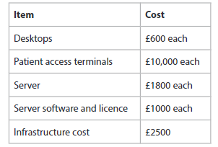

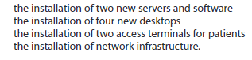

2 new servers = 3600 2 new software = 2000

4 new desktop = 2400

2 Patient access = 20000

Infrastructure cost = 2500

3600+2000+2400+20000+2500 = 30500

